

Care & Cure Hospital

Hospital Management System

Version 02

prepared by :

1. Mahmoud Mohamed Fouad

2. Mamdouh Marouf

Published Date

01/03/2021

Document Version

D V: 02

Table of Contents

Table of Contents 1

Revision History 2

1. Introduction 2

1.1 Purpose 2

1.2 Product Scope 2

1.3 References 3

2. Overall Description 3

2.1 Product Overview 3

2.2 Product Perspective 3

2.3 User Classes and Characteristics 11

2.4 Operating Environment 11

2.5 User Documentation 11

3. External Interface Requirements 12

3.1 User Interfaces 12

3.2 Hardware Interfaces 15

3.3 Software Interfaces 15

3.4 Communications Interfaces 15

4. Other Nonfunctional Requirements 15

4.1 Performance Requirements 15

4.2 Security Requirements 16

4.3 Software Quality Attributes 16

4.4 Business Rules 16

5. Other Requirements 16

Revision History

|  |  |  |  |
| --- | --- | --- | --- |
| **Name** | **Date** | **Reason For Changes** | **Version** |
| Care & Cure Hospital | 25/11/2020 |  | DV:01 |
| Care & Cure Hospital | 01/03/2021 | Adding a new updates of the last version of project | DV:02 |

# 1.Introduction

# 1.1 Purpose

1. provide comfort to the patient when booking and reduce the consumption of time and facilitate the process of booking.
2. Improve service for patient and save their rights in the data of booking not to manipulate appointments.
3. Linking between all departments and all services within the hospital for easy handling and speed.
4. Compatibility Tewfik training courses for doctors easily.
5. Keeping blood groups in a proper way for non-manipulation and the occurrence of seven mistakes.
6. Easy storage and keeping of materials, devices and medical supplies in a proper way.

**1.2 Product Scope :**

The system makes it easy to book and deal with the centers within the hospital and also .The system to carry out training courses for his doctors and nurses And provides the system to call the doctor of abroad .It also helps in repid response and emergency response

1. **Propose:**

* Facilitate booking Processes
* Saving time
* Security observation of manner

1. **Goals :**

* The system is based on labor reduction
* Facilitate the interaction between the patient and the hospital
* Facilitate the way of booking
* Cancel paper transaction
* 24 hours service

.

## **1.3 References**

* [www.google.com](http://www.google.com) .
* [www.wikipedia.org](http://www.wikipedia.org).
* Cairo Hospital.

# 2. Overall Description

## **product Overview**

General description: reservation requirements, providing the customer with time, speed and ease in booking, following up the registration process and controlling data.

## **Product Perspective**

## Hardware interfaces :

Hard disk: The database connectivity requires a hardware  
configuration with a fast database system running on high rpm  
hard-disk permitting complete data redundancy and back-up  
systems to support the primary goal of reliability.  
The system must interface with the standard output device,  
keyboard and mouse to interact with this software.

1. **Software interfaces :**

Oracle database 12 c.

Oracle form builder.

Microsoft visual studio 2013

1. **Operations**

* **On the website**
* The customer login and give the required information, then can access to the application to book a date on the hospital and specify the specialist or doctor in the website.
* **On the desktop application**
* The receptionist enter all information about patient and make to patient a private folder with P-name

The doctor write the Rocha in the computer and send it to his folder and the doctor can confirm the booking and don’t confirm

Affords enroll all information about workers and saved it in the database

The system can allowed to man security to tell of all dangers in the hospital.

**1. Activity Diagram**

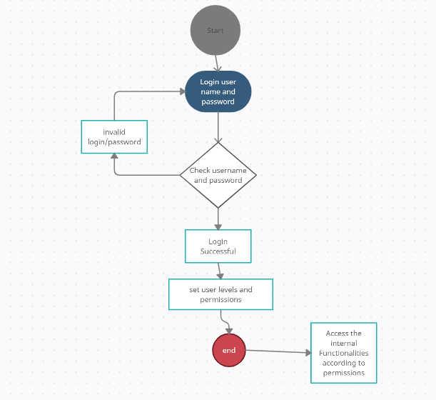

**2. Use Case Diagram:**

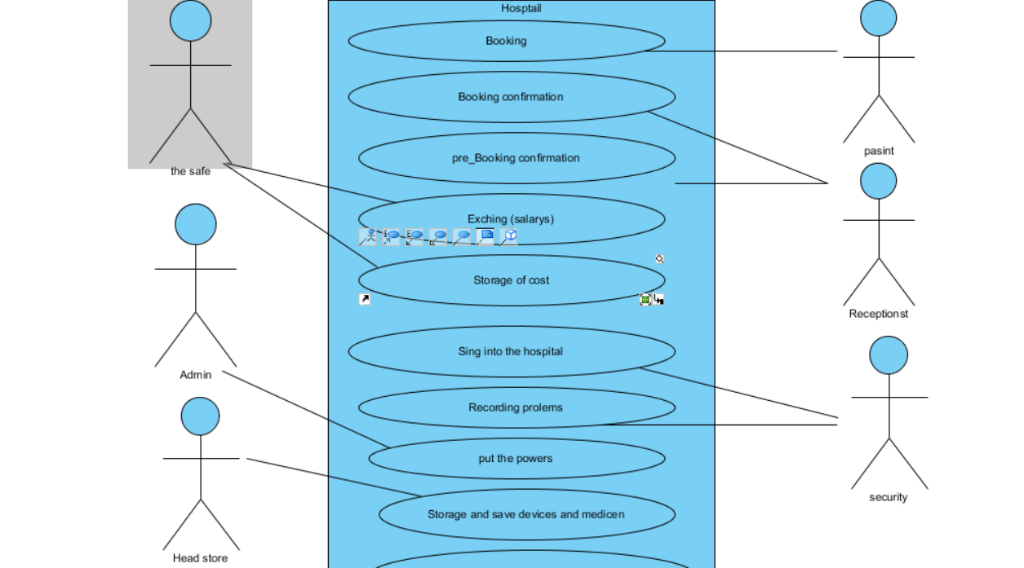

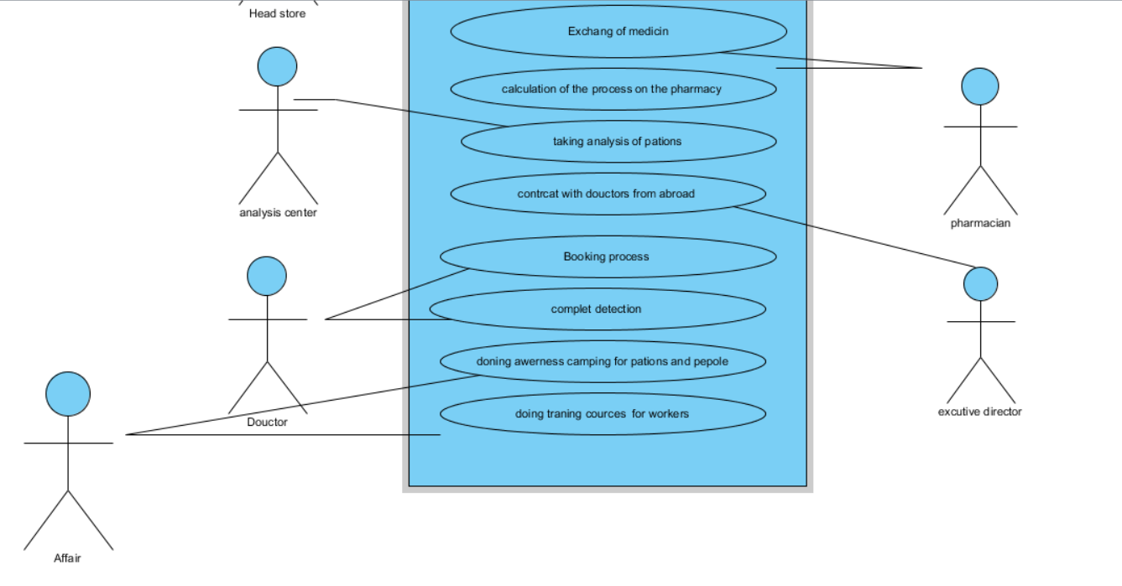

**3. Class Diagram :**

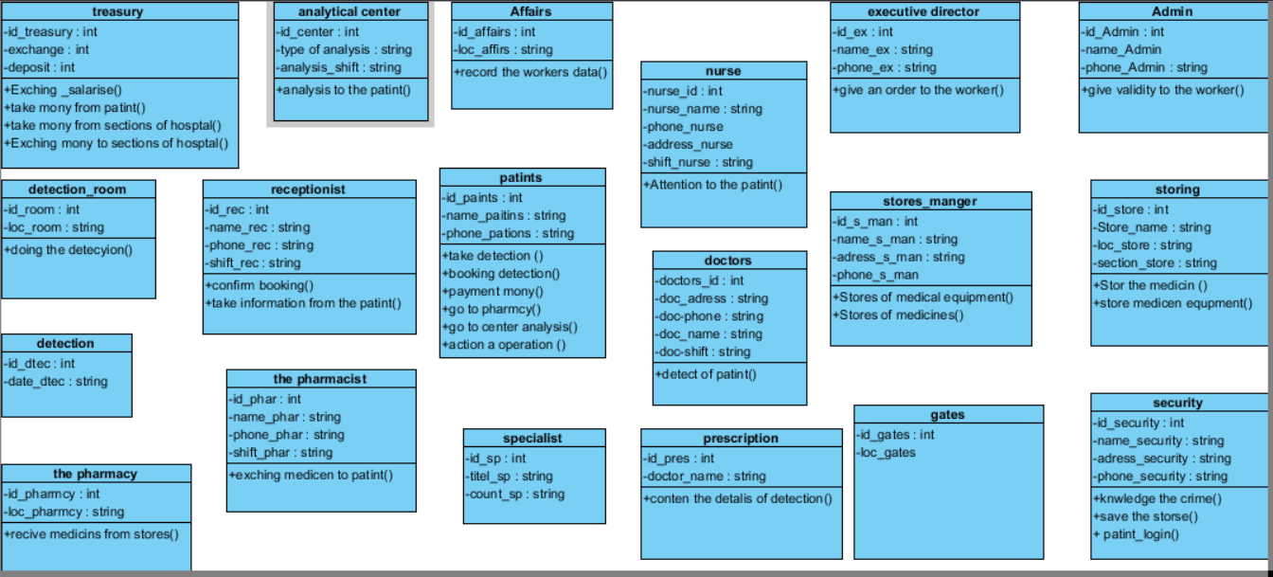

4**. Sequance Diagram :**

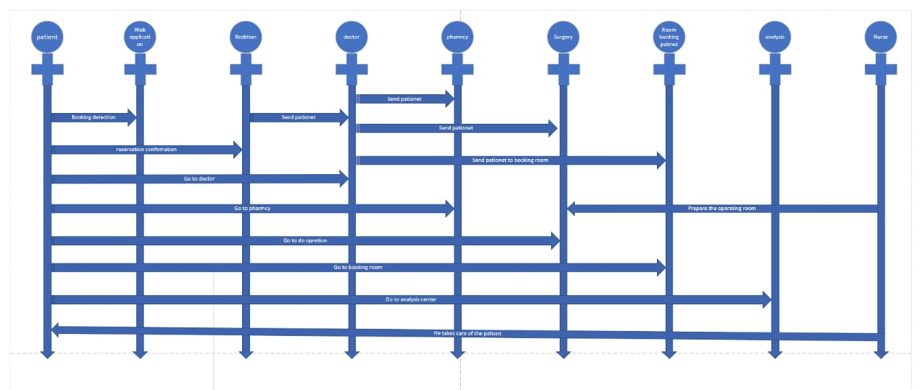

**5. Package Diagrams :**

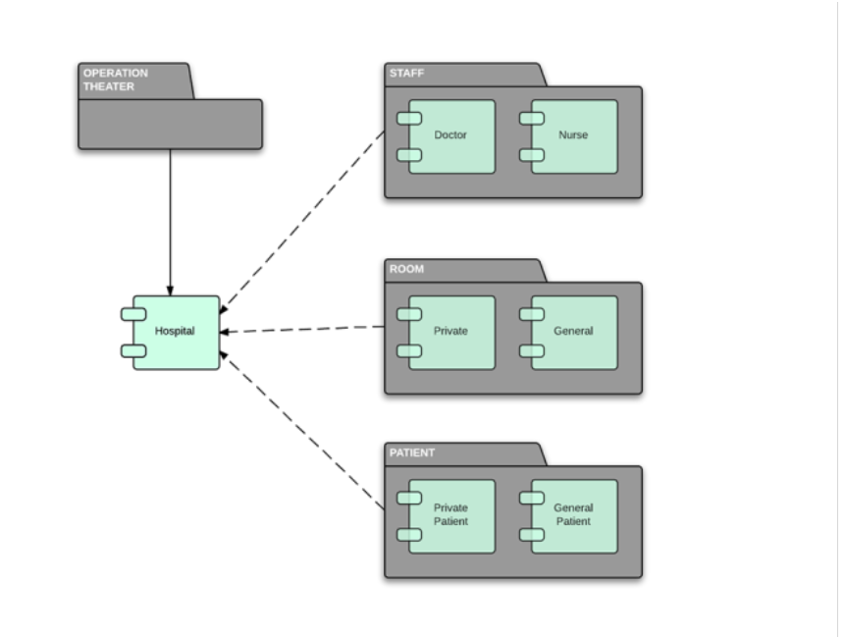

**6. State Diagrams :**

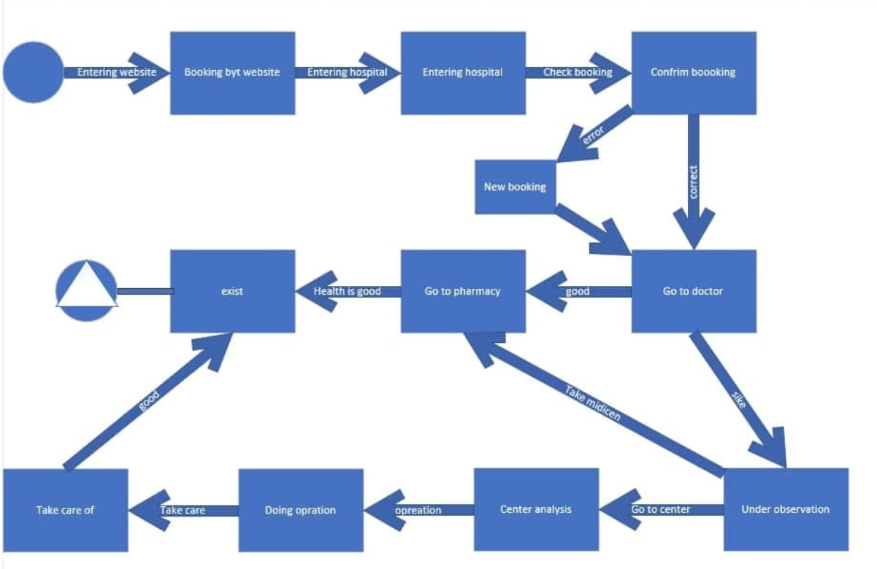

## **4. User Classes and Characteristics:**

There are many kinds of users for Hospital. is the patient , the administrator , Employees ,Nurses ,Exeutive manger ,Pharmcyian and Doctor . The patient do not need to have any prior training to use the system, because the instruction for registration is very simple and everything is visiable. The all of employees would however need to be trained in order to use the system. The last is the administrator would manage all of these operations

## **4.1 Operating Environment**

1-The system will be operating on:

Windows operating system (windows 8.0 or higher)

Web browser

2.1 **User Documentation**

## 1 - Online training course

## 2- Books, notes

# 3. External Interface Requirements

## User Interfaces

**1. Login Interfaces**

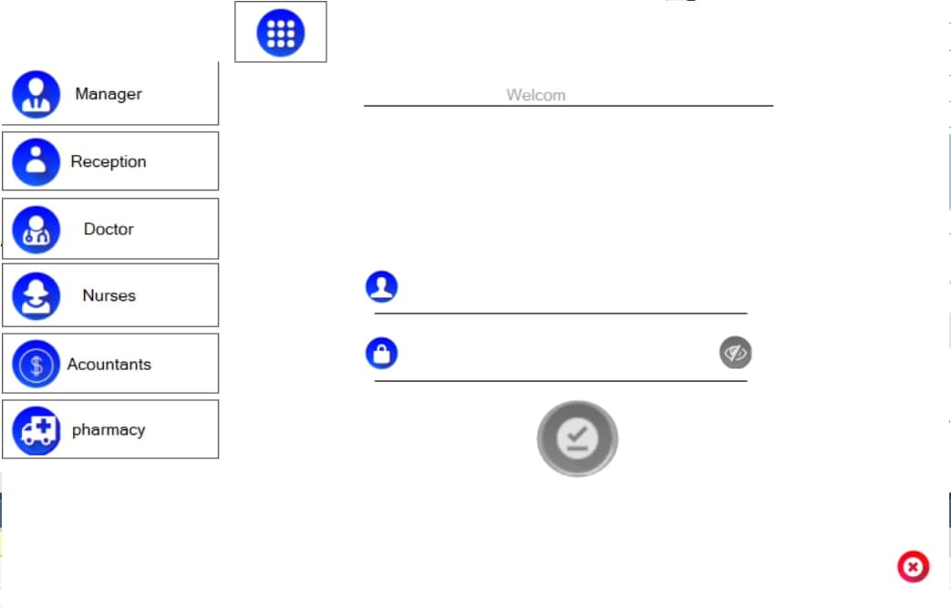

**2. Manager Interface**

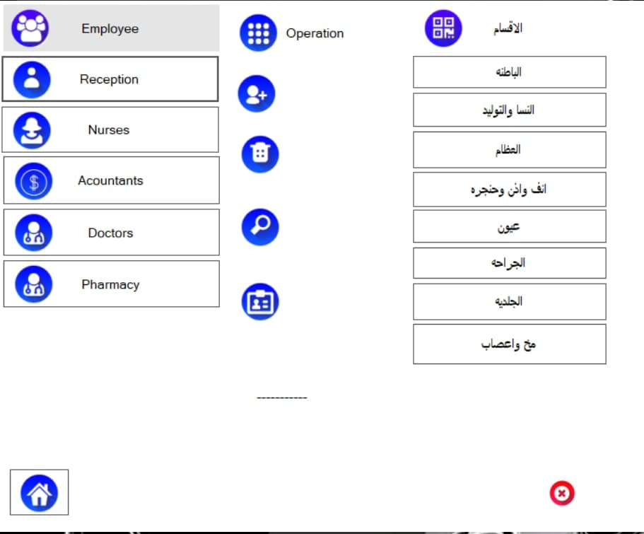

**3. Reception interface**

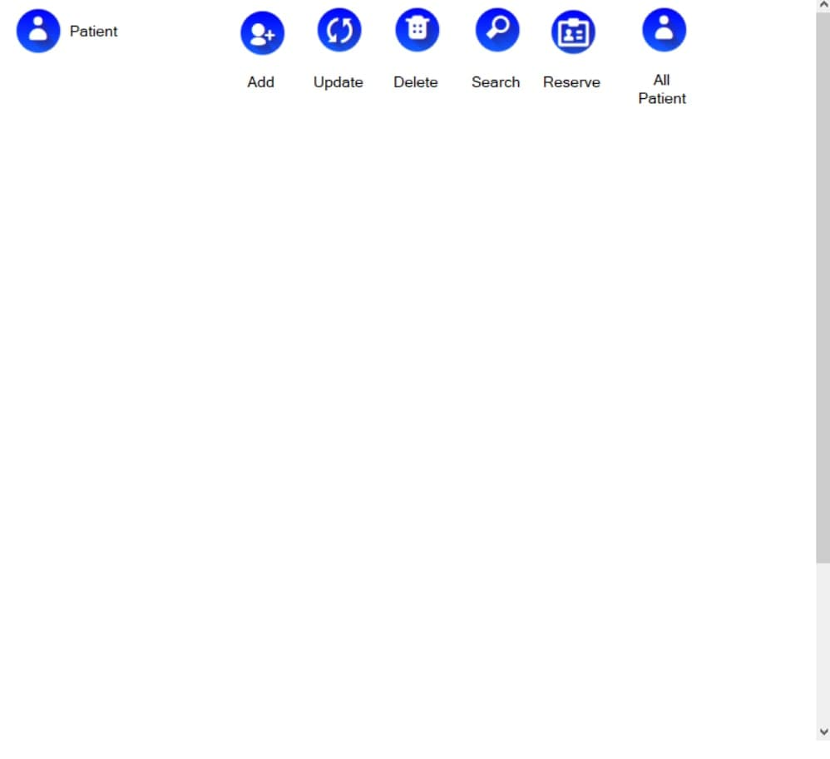**4. Accountant Interface :**

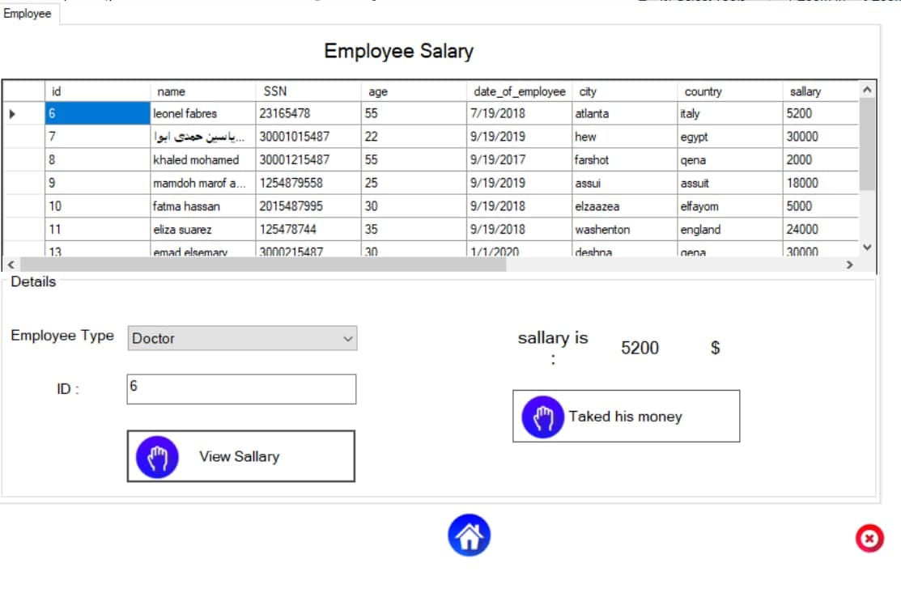

**5.Pharmacyan Interface :**

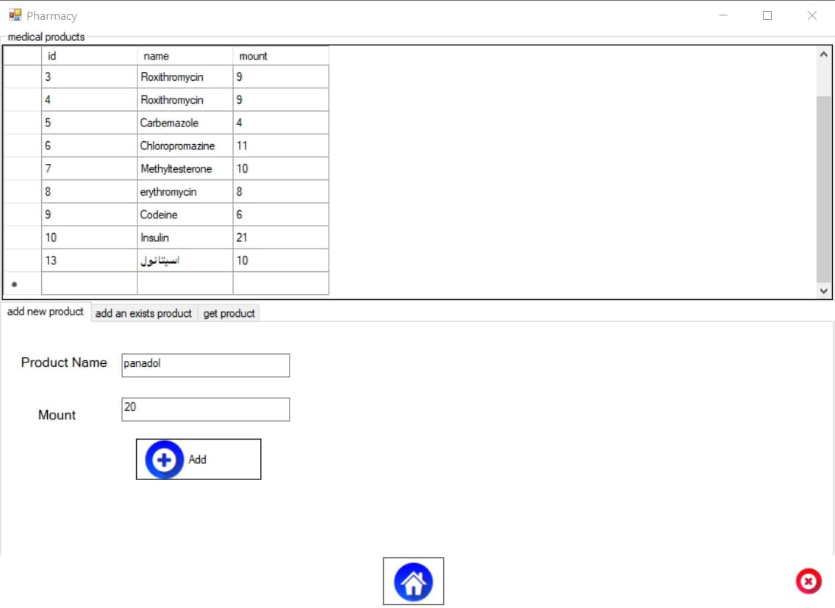**6. Doctor and Nurse Interface :**

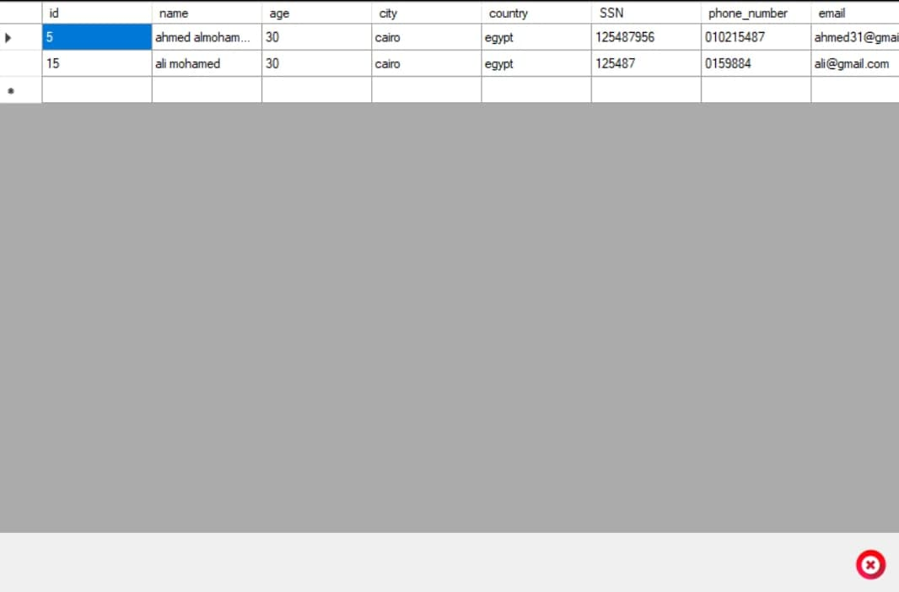

## **Hardware Interfaces**

Hard disk: The database connectivity requires a hardware

configuration with a fast database system running on high rpm

hard-disk permitting complete data redundancy and back-up

systems to support the primary goal of reliability.

The system must interface with the standard output device,

keyboard and mouse to interact with this software

## **Software Interfaces**

Users will use application program via the user interface program. The System must has connection to the database management system

## **Communications Interfaces**

The system requires an internet connection to control the devices remotely, update already installed ones and update some of its components

# System Features

<This template illustrates organizing the functional requirements for the product by system features, the major services provided by the product. You may prefer to organize this section by use case, mode of operation, user class, object class, functional hierarchy, or combinations of these, whatever makes the most logical sense for your product.>

# 4. Other Nonfunctional Requirements

## **4.1 Performance Requirements**

The System requires many types of sensors and servers and transistors, heat and good electrical connection, high internet connection and large memory size. These requirements can support effectively on the system .However, performance depends on Sensor efficiency and capabilities

## **4.2 Security Requirements**

We will use Oracle database and protocols for networks such as TCP and UDP. Delivers all web requests and responses using strong encryption and supports all web applications, programming languages and SSL We will use Gtmetrix to test application performance

4.3 **Software Quality Attributes**

The System provides the users with both simple and advanced features. Due to its well designed and easy to use interface . also it can be accessed and controlled from anywhere . It can be used on computers or mobile phones

## **4.4 Business Rules**

The system can allow its use through the booking staff in all cases and there are emergency cases the employee must book in a different way and our system facilitates this process simple tools and easy to use and the system distributes cases to doctors and the importance of the patient's situation in the consideration of doctors and the patient has a full record in front of the doctor to review his condition and the system allows use Easily in this case

# 5 .Other Requirements

Glossary:

Sensors: A sensor is a device that detects and responds to some type of input from the physical environment.

Environmental sensors: a set of sensors used to measure different environmental factors such as illumination and ambient air temperature